**Year 12 Physics**

**Task 4 – Circular Motion, Gravity and Equilibrium Test**

**Weighting: 5%**

**Total Marks: 55**

**Date: _________________________**

**Time allowed: 55 minutes**

**Student Name: _____________________**

**Mark: _______/55**

*I acknowledge that all the information contained in this task is my own work and not taken from other sources. If other sources have been used they have been acknowledged in my references.*

_____________________________________________________

(Student Signature)

Refer to data sheet for relevant formulae and constants.

Show full working and express all answers to **three (3)** significant figures. When estimating numerical answers, show your working or reasoning clearly and give final answers to a maximum of **two** **(2)** significant figures. Include appropriate units where applicable.

1. 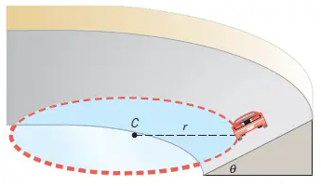A 950 kg vehicle is traversing a curve of radius 30.0 m, banked at an angle of 40.0⁰ to the horizontal.
   1. Derive a formula for the speed required for the vehicle to navigate the curve without relying on friction, and then calculate this speed.

Include any relevant diagram(s).

(4 marks)

Answer: _______________ m s-1

* 1. Calculate the magnitude of the normal force acting on the vehicle.

(2 marks)

Answer: _____________ N

* 1. The driver is in a rush and takes the curve at a speed of 25.0 m/s. State the effect this will have on the **magnitude** of ***each*** of the forces involved.

(4 marks)

____________________________________________________________________________________________________________________________________________________________________________________________________________________________________________________________________________________________________________________________________________________________________________________________________________________________________

__________________________________________________________________________________________________________________________________________________________________________________________________________________

1. 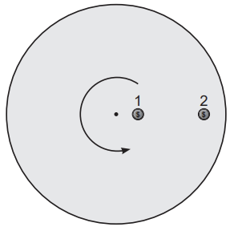Two identical 20.0 g coins are placed on a rotating disc, 0.350 m and 1.40 m respectively from the centre of the disc. The disc begins to rotate. When the frequency of rotation reaches 3.00 Hz, the outer coin flies off the disc.

Calculate the frequency of rotation when the inner coin flies off.

(6 marks)

Answer: ______________ Hz

1. The following roller-coaster ride is entirely gravity-driven and frictionless; the cart is allowed to roll from a height ‘h’ above the ground without any form of power, gathering enough speed to pass through the loop without falling from the track.

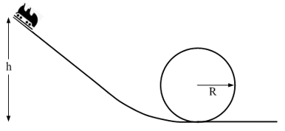

The radius of the loop is 6.00 m. The mass of the cart, with passengers, is 1150 kg.

The initial velocity, at the top of the track, is 0 m/s.

* 1. With reference to the forces involved, state the condition required to ensure that the cart ***just*** remains in contact with the track at the top of the loop.

(1 mark)

__________________________________________________________________________________________________________________________________________________________________________________________________________________

______________________________________________________________________

* 1. Calculate the **minimum** speed required at the top of the loop to ensure that the cart *just* remains in contact with the track.

(2 marks)

Answer: _______________ m s-1

* 1. Calculate the **minimum height** ‘h’ from which the cart can be released to ensure the cart reaches this minimum speed at the top of the loop *(use v = 7.70 m/s if you couldn’t solve b.)*.

(3 marks)

Answer: _________________ m

* 1. Calculate the magnitude of the normal force on the cart at the bottom of the loop.

(4 marks)

Answer: ___________________ N

1. A satellite in a Medium-Earth Orbit (approximately 20000 km orbital radius) is moved to a geosynchronous orbit.
   1. Compare and contrast a geostationary and geosynchronous orbit.

(2 marks)

__________________________________________________________________________________________________________________________________________________________________________________________________________________

______________________________________________________________________

* 1. Calculate the height (altitude) of the satellite above the earth’s surface in the geosynchronous orbit.

(4 marks)

Answer: ___________________ m

1. Proxima b is a planet orbiting our neighbour star, Alpha Centauri. Observations reveal Proxima b is 1.30 times more massive than our own planet and orbits 7.50 x 109 m from Alpha Centauri. Proxima b’s orbit around its sun lasts 11.2 Earth days.
   1. Calculate the mass of Alpha Centauri.

(3 marks)

Answer: ______________________ kg

* 1. Calculate the acceleration of Proxima b as it orbits Alpha Centauri. *(If you could not obtain an answer to part (a) you may use 2.60 × 1029 kg.)*

(2 marks)

Answer: __________________ m s-2

* 1. Explain the effect on Proxima b’s orbital period if the planet was double its current mass.

(2 marks)

__________________________________________________________________________________________________________________________________________________________________________________________________________________

__________________________________________________________________________________________________________________________________________________________________________________________________________________

1. Hugh and Greg are sitting on a see-saw; Hugh has a mass of 40.0 kg, whereas Greg has a mass of 60.0 kg. Greg is sitting 1.50 m from the fulcrum.
   1. What is the magnitude of the force exerted by the fulcrum on the see-saw beam?

(2 marks)

Answer: ______________ N

* 1. How far from the fulcrum must Hugh sit to balance Greg?

(2 marks)

Answer: _________________ m

1. A sign for a cake shop has been suspended from the ceiling by two wires, each able to sustain a maximum force of 65 N. The sign has a mass of 4.00 kg. Calculate the tension force present in each wire and determine whether or not either wire shall fail (break).

The Cake is a Lie!

TA

TB

50˚



(4 Marks)

1. A 3.30 m long, uniform ladder leaning against a frictionless wall makes an angle of 59.0° with the horizontal. There is a man standing on the ladder. The ladder's mass is 12.0 kg while the man has a 68.0 kg mass. The man's feet are located 1.20 m above the floor.
   1. Calculate the reaction force acting on the ladder, provided by the wall.

(4 marks)



Answer: _______________ N

* 1. Calculate the reaction force acting on the ladder, provided by the floor.

(4 marks)

Answer: __________________________ N Direction:________________________

**END OF TEST**